📝 Notes
Apr 29, 2026

Contained Animal Management System | Solution Lab 3
Invited Christian Ruiz Francisco Perez Tyler Morton Raul Montenegro Claudiu Constantin wyldsolconsulting@gmail.com
Attachments Contained Animal Management System | Solution Lab 3
Meeting records Transcript Recording

Summary
The team refined MVP feature flows via user journey mapping and defined key inventory management requirements.
Defining MVP User Journeys
The team solidified the MVP feature list including onboarding, inventory management, and media handling. They decided to utilize email and password authentication for initial user access.
Inventory and Media Strategy
Users will utilize Brand IDs as primary animal identifiers and implement bulk import features for data. The group concluded that inactive status replaces deletion to maintain historical record integrity.
Settings and Financial Flows
Development priorities now include custom status, location settings, and headcount-based subscription tiers. The team chose to manage payment friction by using interactive carousel displays on mobile devices.

Rate this Summary: Helpful or Not Helpful

Decisions
We've updated the Decisions section using your feedback.
Let us know what you think: Helpful or Not Helpful

NEEDS FURTHER DISCUSSION
- Media storage limit definition The establishment of hard storage limits for user media is deferred until sufficient usage data is collected to determine competitive pricing.

ALIGNED
- Email and password authentication adopted Email and password will be the sole authentication method for the MVP to minimize development complexity.
- Account ownership model adopted The platform will utilize an ownership model where each user manages their own account and invites others with specific roles, rather than assigning roles during setup.
- Bulk import feature included An import feature for existing inventory (Excel/CSV) will be provided during onboarding to facilitate user migration.
- Mobile pricing carousel implementation Mobile pricing tiers will be displayed using a swipeable carousel with a drawer for detailed comparison to reduce user friction.
- Animal deletion disabled Animal deletion is disabled in favor of using system statuses to mark records as inactive for historical retention.
- Events included as tags Events will be included in the MVP as tags to allow for media filtering and tracking.
- Standardized import template adoption A standardized Excel/CSV import template will be enforced for bulk data migration to minimize processing errors and standardize data hierarchy.
- Guided onboarding wizard adopted A guided wizard will be implemented for the onboarding and import flow to manage complex setups.
- Media format support confirmed The platform will support pictures, videos, and custom links as the media formats for animals.
- Brand ID primary identifier Brand ID is established as the primary identifier for animals, taking precedence over names in table views and data sorting.
- Offline media sync strategy Media uploads will utilize local storage to enable offline functionality and retries, ensuring no data loss during poor connectivity.
- Notification channels selected Notification channels for the MVP will consist of push notifications and text messages.
- Partners directory feature consolidated User roles and management features will be merged into a unified "Partners Directory" to simplify internal management.
- Threaded comment functionality confirmed Threaded comment functionality is confirmed for both animal profiles and media items to facilitate communication.
- Expense tracking feature implementation deferred The implementation of animal expense tracking and bill splitting is deferred to a later date as a separate function, following the initial invoicing implementation.
- Standard credit card payment method The subscription payment method is set to standard credit card processing.
- Subscription tiers based on headcount The subscription tiers are set to be based primarily on animal headcount, with partner access restricted to read-only.

Next steps
- [WyldSol] Update Social Login: Add exclusion of Facebook social login for initial launch to list.
- [WyldSol] Create Payment Flows: Design distinct platform flows for each user role and payment tier setup.
- [WyldSol] Document Status Flow: Develop flow documentation detailing required system statuses.
- [WyldSol] Confirm Ownership Rules: Determine preferred method to identify animal owner status: percentage or specific selection.
- [Claudiu Constantin] Adjust Display Hierarchy: Note requirement to prioritize Brand ID over animal Name in the table view.
- [Christian Ruiz] Research Offline Media: Investigate optimal strategy for storing media locally to enable background upload and retry functions.
- [WyldSol] Review Partner Directory: Examine and provide feedback on the merged partners directory structure and workflows.
- [Claudiu Constantin] Research Storage: Compare storage costs and limits using other services. Establish competitive pricing structure for media storage add-ons.
- [Francisco Perez] Share Board: Share the link to this board with attendees.
- [WyldSol] Research Figure: Look up information regarding Temple Grandin.

Details
Did the screenshots in this section make your notes better or worse?
- MVP Flow Focus and User Journey Map: Francisco Perez introduced the focus of the current session, which is to concentrate on the Minimum Viable Product (MVP) flows to prepare Claudiu Constantin for higher fidelity design work. The exercise involves reviewing a user journey map that outlines typical user steps within the application, mapping out individual user actions (features), and identifying potential pain points for consideration during design and implementation (00:00:00).
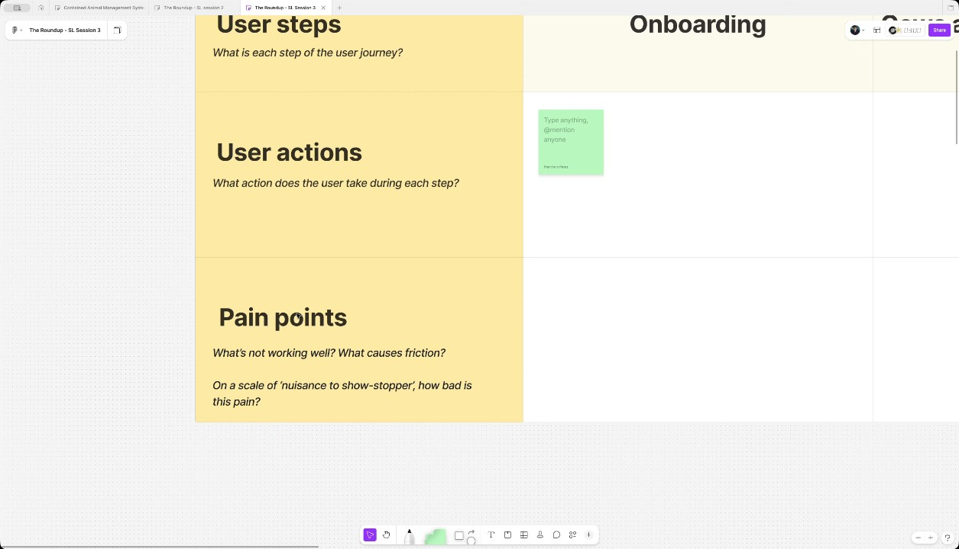
- Review of MVP User Steps: Francisco Perez reviewed the proposed list of user steps for the MVP, which includes user onboarding, inventory management (previously called cows and bulls management), media management, notifications, media access, analytics, and payment flows (00:00:59). WyldSol confirmed that this list aligns with the screens they had considered (00:02:07).
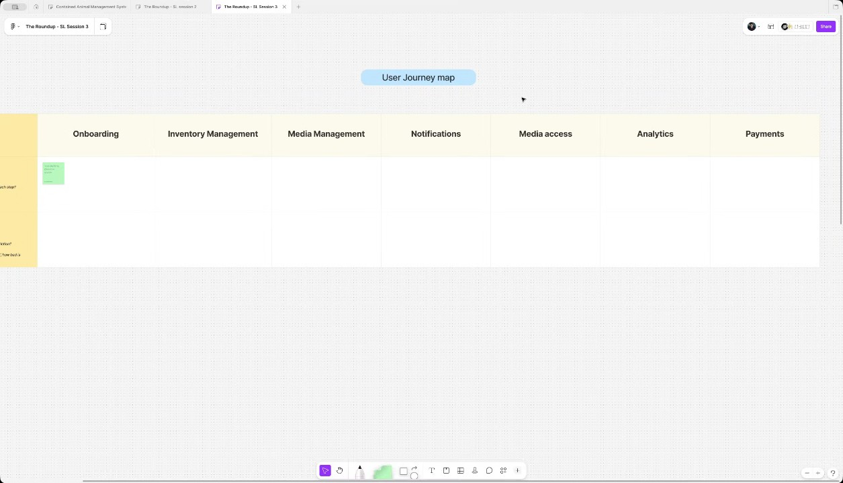
- Incorporation of Settings into User Steps: Following a discussion, Francisco Perez confirmed the addition of a 'Settings' step to the list of MVP flows. This step covers the features for configuring metadata such as animal status and location (00:02:07). WyldSol agreed that including settings completed the necessary steps for the MVP (00:03:04).
- Onboarding: Social Login Requirement: Francisco Perez asked if social login should be offered for the MVP, noting its importance for app stores, but questioning its priority over email/password login (00:03:04). WyldSol suggested that email/password login is sufficient for the first round, and noted that most of their users are on Facebook. They decided to proceed with just email and password, as social logins like Facebook, Apple, and Google require effort investment (00:04:08).
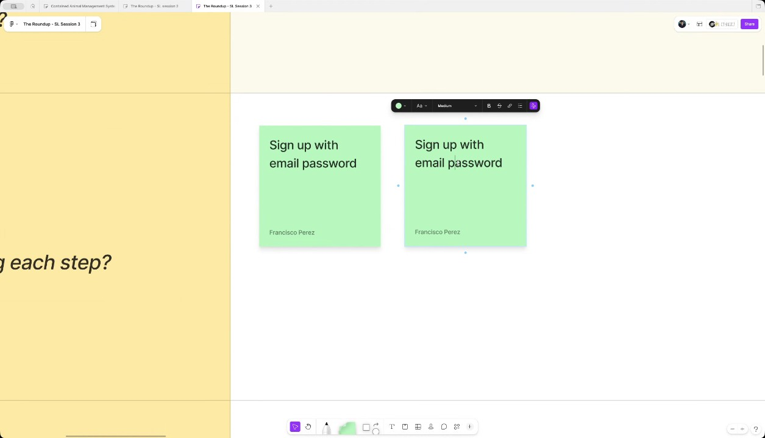
- Onboarding: Clarifying User Roles and Payment Model: Claudiu Constantin brought up questions about onboarding different roles (rancher/trainer, bull owner, partner/investor) and how subscriptions are handled, assuming the rancher/trainer is the sole payer who invites others (00:05:08). WyldSol clarified that everyone who signs up would be the owner of their own account and would pay. Invitees would not pay initially, but WyldSol later corrected this, confirming invitees will also have to pay (00:06:26).
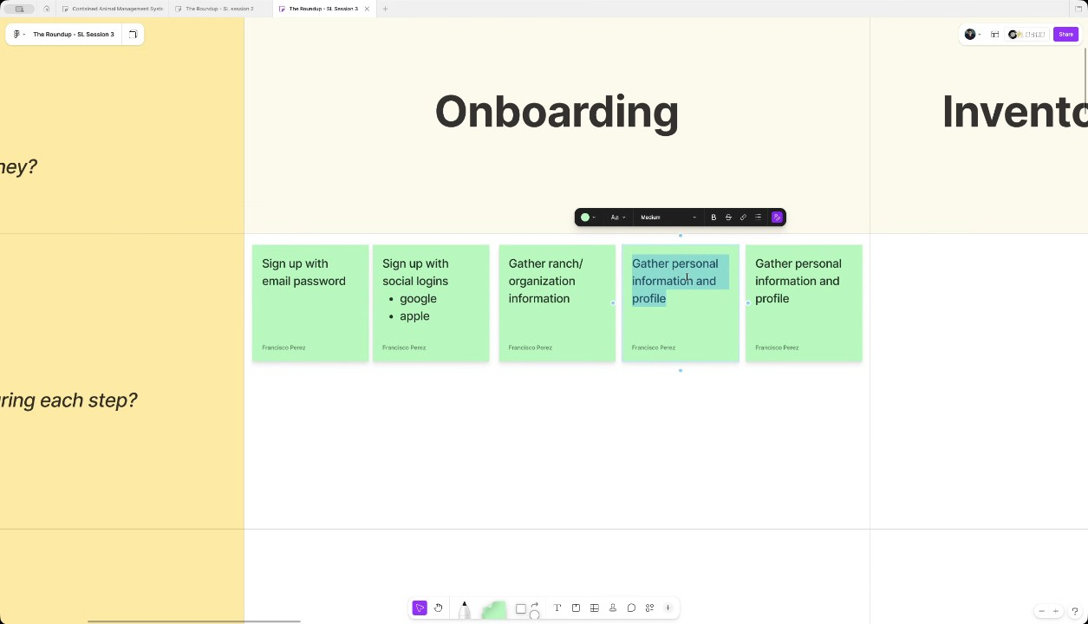
- Subscription and Role Hierarchy: The discussion clarified that user roles are defined by their relationship to the owner or the animals, and everyone has ownership of their own account, which ties into the subscription model (00:08:46). Everyone creates an account, and then they invite others, assuming different roles (e.g., partner, bull owner) based on animal sharing, making every user a first-class citizen in their own platform (00:10:05). WyldSol committed to creating a flow for each role and payment tier (00:11:12).
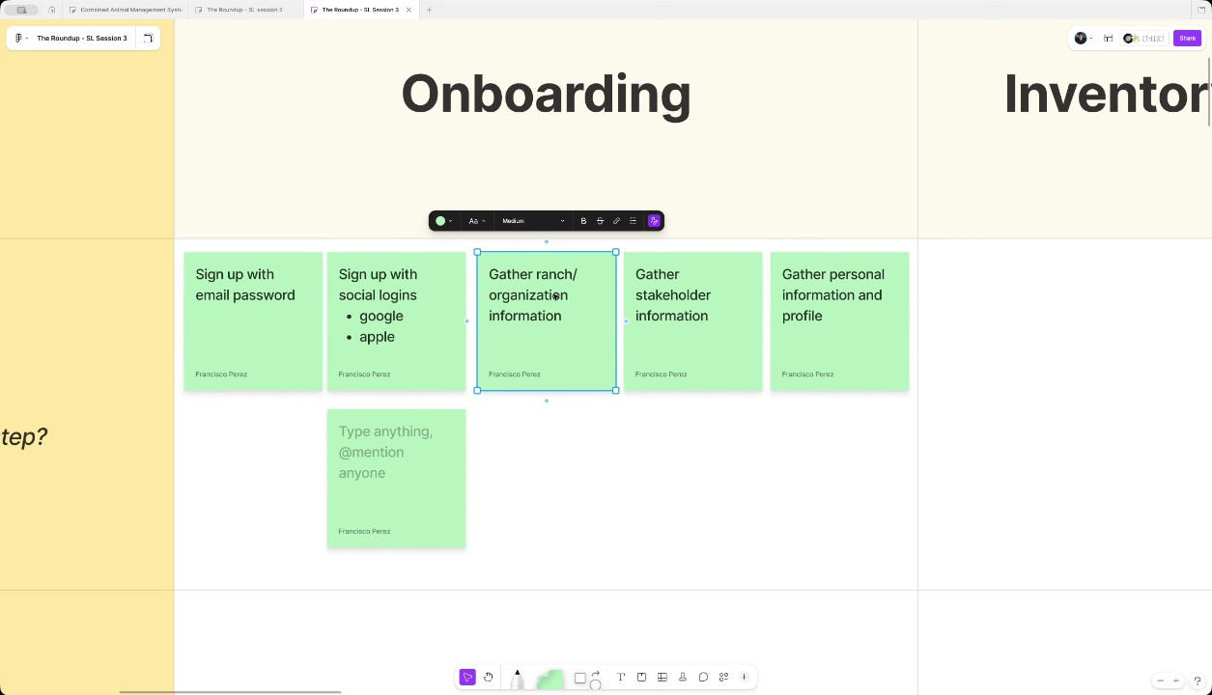
- Onboarding Pain Points and Payment Prompt: A potential pain point was identified regarding the prompt for payment during onboarding. Francisco Perez noted that requesting payment immediately is a friction point, requiring strong communication of the app's features to eliminate doubt (00:13:52). WyldSol raised the issue that presenting complex tier information on mobile could be difficult, suggesting purchasing might need to occur on the web (00:15:05).
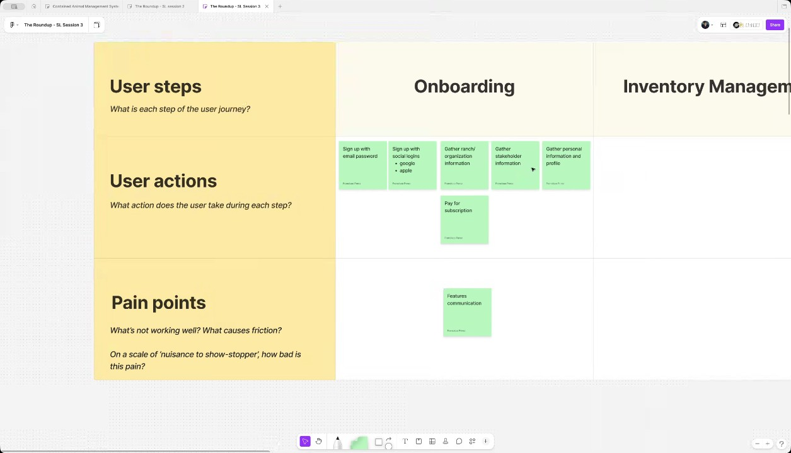
- Addressing Payment Friction on Mobile: Claudiu Constantin proposed that pricing tiers should be displayed on mobile using a carousel or slide format to reduce friction, avoiding derailing the user's onboarding process (00:16:09). They suggested having two states: one with minimal tier listings and another with an in-depth comparison via a pop-up drawer to help users decide. WyldSol noted that the key indicator for tier selection is the number of animals a user has (00:17:24).
- Import Feature for Bulk Onboarding: To minimize the friction of migrating data, the team discussed offering an import feature during or immediately following onboarding (00:12:28) (00:18:24). This would allow users to easily add their entire inventory, likely from Excel or Google Sheets, which WyldSol confirmed are the most common in-house data management methods (00:19:18). A template and guided wizard approach was suggested for the MVP to standardize data import and provide self-training on the system's structure (00:27:11).
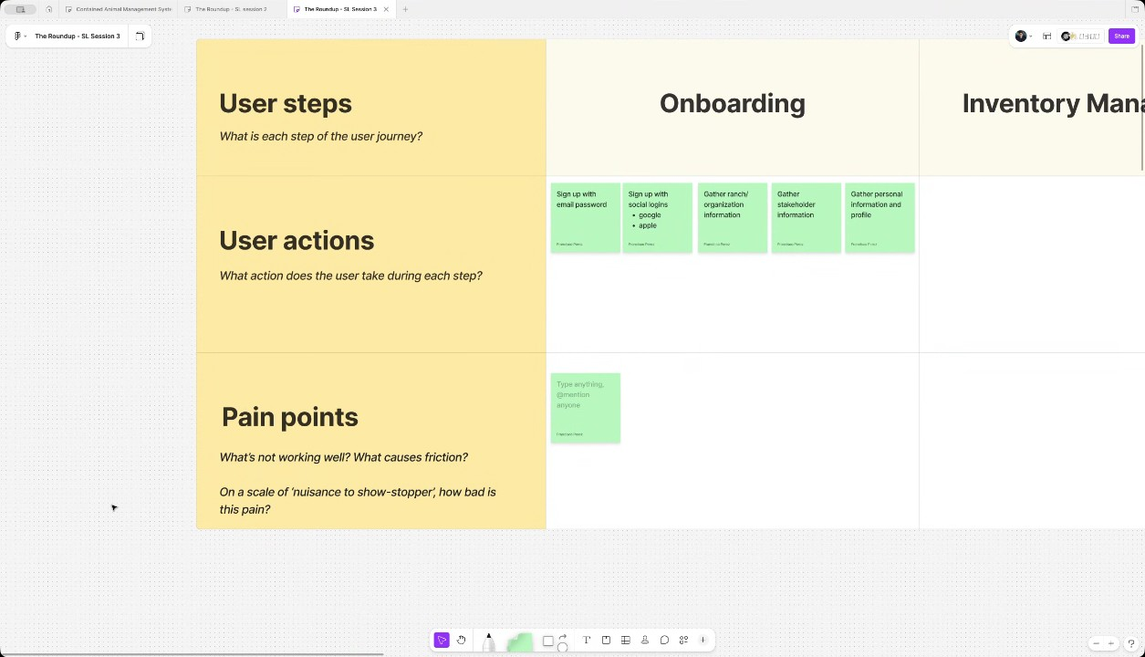
- Managing Inventory Updates and Deletion: Regarding inventory management, the team concluded that editing animals is standard, but deleting animals should be avoided. Instead of deletion, animals should be marked as "inactive" using system statuses to preserve media and history. WyldSol will create a flow for system statuses and user-defined indicators (00:21:35).
- Inventory Management and Events/Partnerships: It was confirmed that inventory management must include managing partnerships, which is a major feature. The team decided that events should be included in the MVP, perhaps as tags on media, because events are a significant source of media (00:23:02).
- Friction Points in Bulk Inventory Import: The potential for friction in the bulk import process was discussed, specifically concerning the effort required for users to adapt their existing spreadsheets to the system's template and the need for configuration items (like custom statuses) to be pre-existing when the bulk upload occurs (00:28:20). Claudiu Constantin suggested a guided wizard for onboarding that allows users to sign up even if they skip details, relying on a dashboard to-do list for later configuration (00:29:11).
- Handling Duplicates and Ownership During Import: Claudiu Constantin highlighted the importance of detecting duplicates during animal import and managing the assignment of roles, especially in terms of identifying the animal's owner (00:30:14). The owner is defined by the ability to edit the animal in the system. WyldSol committed to confirming whether ownership should be determined by the highest percentage of investment or by a specific selection (00:32:20).
- Media Management Features: For media management, the supported formats are pictures, videos, and links (00:33:32). The primary flow is point-and-shoot: opening an animal's profile and taking a picture (00:43:42). Tagging is crucial, and tags will include the animal's name, date, age, and brand ID (00:36:12). Users can also upload media in bulk from their phone library (00:37:48).
- Handling Offline Media Uploads: WyldSol emphasized that handling offline media uploads and retries is crucial for the MVP user experience, as the videos are central to their business. The technical team plans to leverage local storage and a retry mechanism for background uploads when internet is available (00:40:05).
- Brand ID as the Primary Animal Identifier: The team decided that the Brand ID should be the primary identifier shown in the inventory view, ahead of the animal's name, because not all animals will have names, but they will always have a Brand ID (00:36:12).
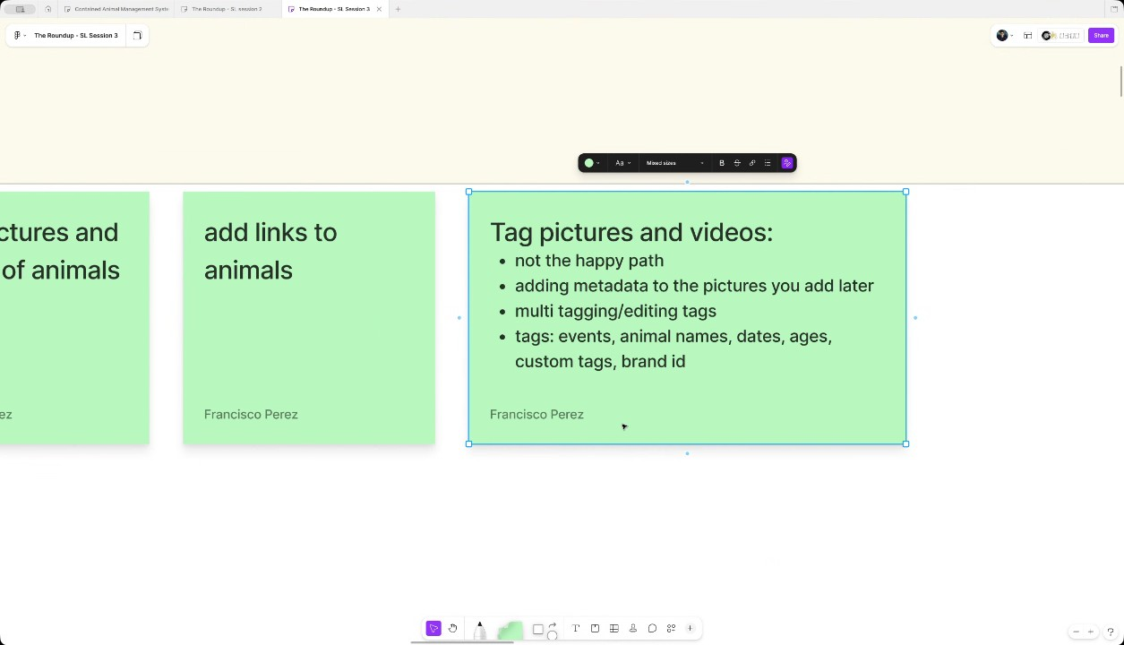
- Public and Private Media Status: The concept of public and private media was introduced. Private media is only visible to the sole owner/uploader, while public media is accessible to all stakeholders (00:43:42). Private media remains with the previous owner even after an animal is sold, providing historical data for the ranch/services (00:44:51).
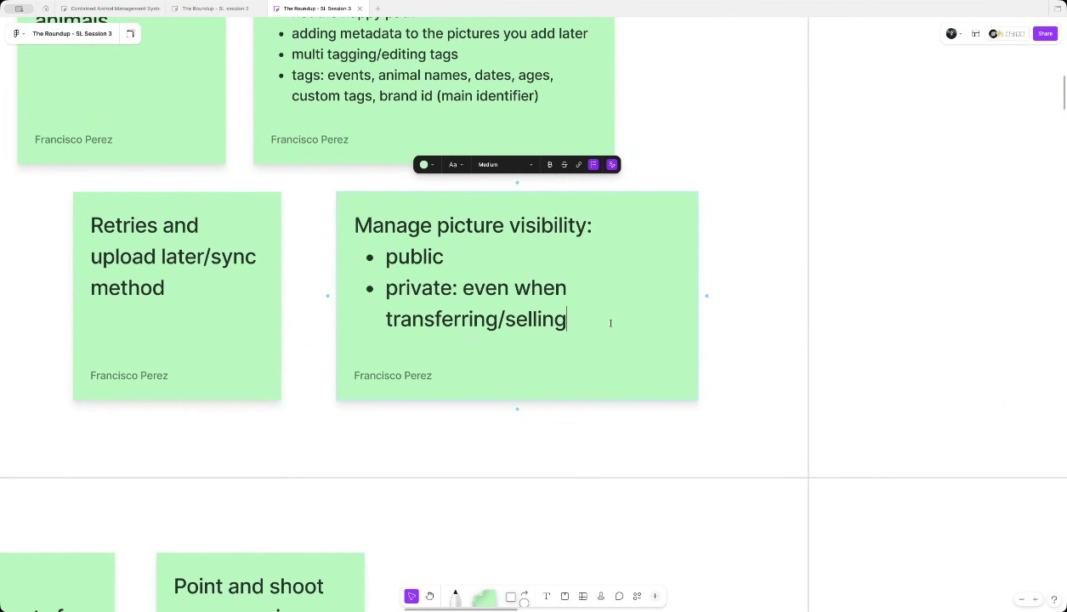
- Notification Channels and Scope: The preferred notification channels for the MVP are push and text messages, utilizing the user's contact list. Notifications will be a broadcast subscription for all partners and stakeholders regarding media updates (00:46:20). Invites, however, will primarily be sent via email, though custom invite links using social share sheets (WhatsApp, SMS, etc.) on mobile devices is preferred for ease of use (00:47:28).
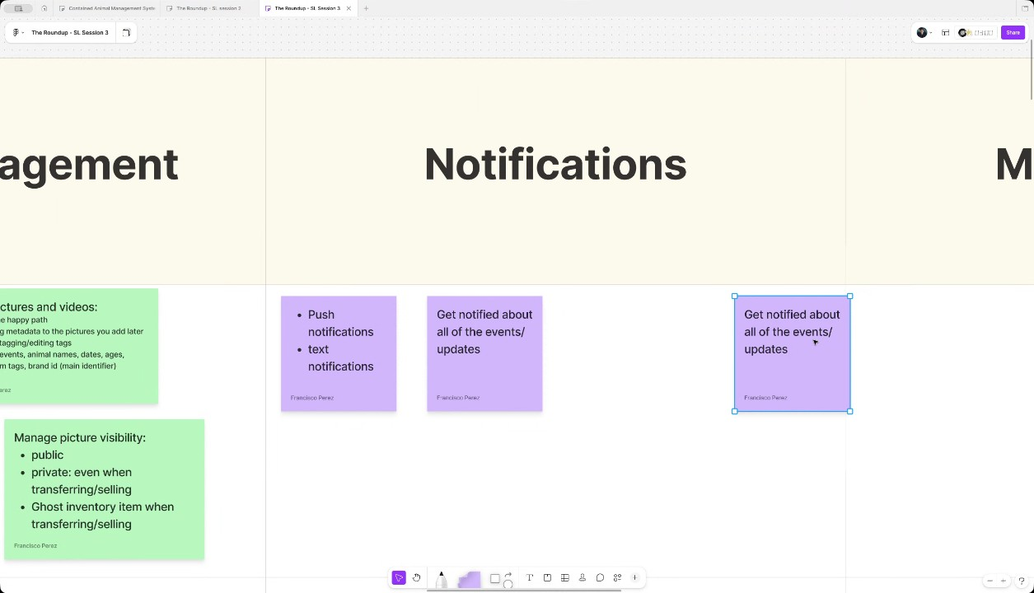
- Media Access Filtering and Interactions: Key features for media access include browsing via a gallery view per animal, filtering, and searching based on tags (00:51:08). Sorting by date (most recent) is also necessary. The core interaction will be a thread commenting ability (without social reactions like "liking"), and users must be able to download and save media files (00:52:23).
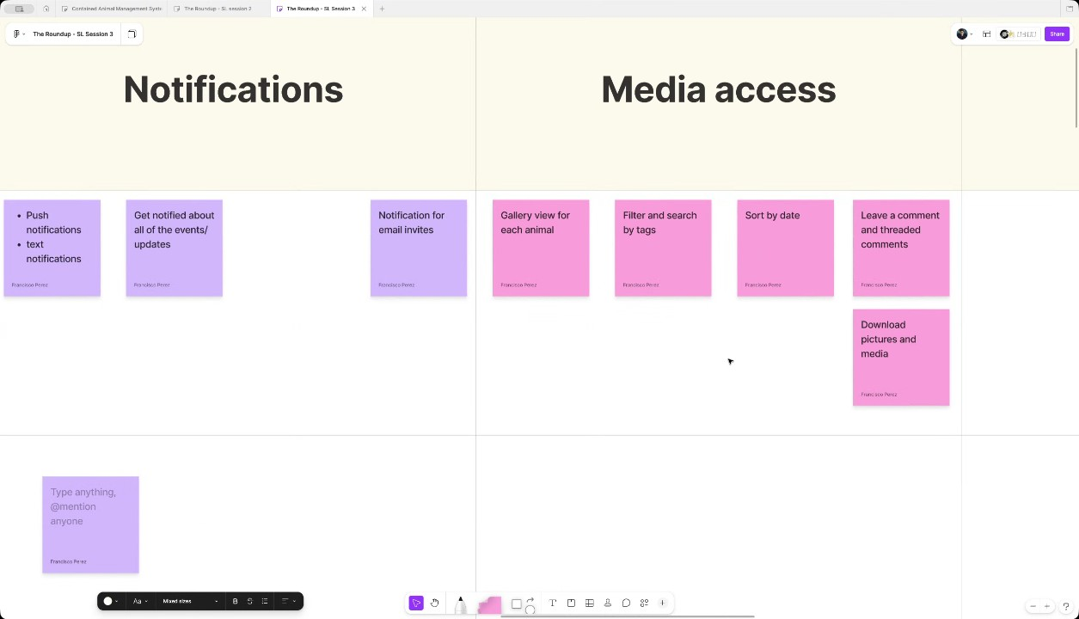
- Role Display in Comments and Animal Profile: For comments, the display should show the date and the commenter's name, but not their specific role (partner, owner) to keep it simple. WyldSol also requested that a thread comment ability be added to the animal profile, not just the media (00:54:03).
- Analytics for MVP: The MVP analytics will focus on simple metrics, primarily the number of animals per status (00:55:35). Investment details, specifically how much was paid when buying and sold when selling, are also important metrics they want to see (00:56:51).
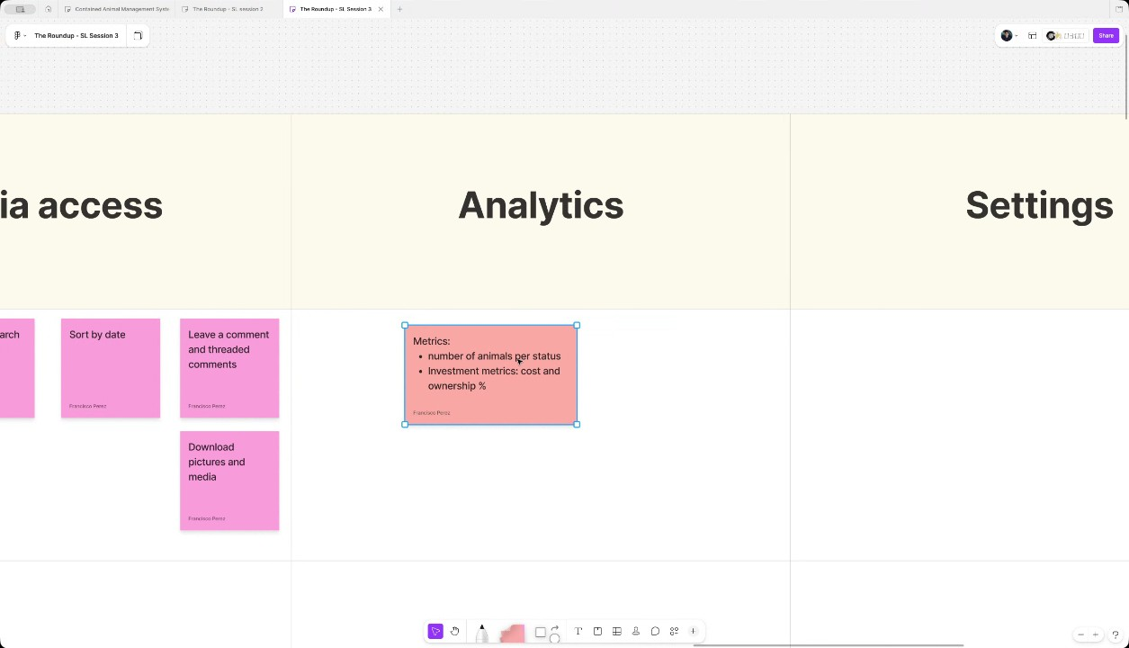
- Discussion of Dashboard Metrics and Visualizations: The current dashboard includes basic metrics such as active animals in care, upcoming events, and invoicing status. Stats are also broken down by competitions, detailing events participated in, total winnings, average scores, and win rate, which is also tracked per animal. The team agreed that the dashboard will be built further once more information and features are available (00:58:14).
- Review of Settings Area Features: The settings area is planned to include custom statuses and tags, ranch setup information, and media management. Claudiu Constantin also suggested a default settings area for items like daily care rates, currency, and fiscal year start, which are necessary for accounting and splitting expenses across partners (00:59:42).
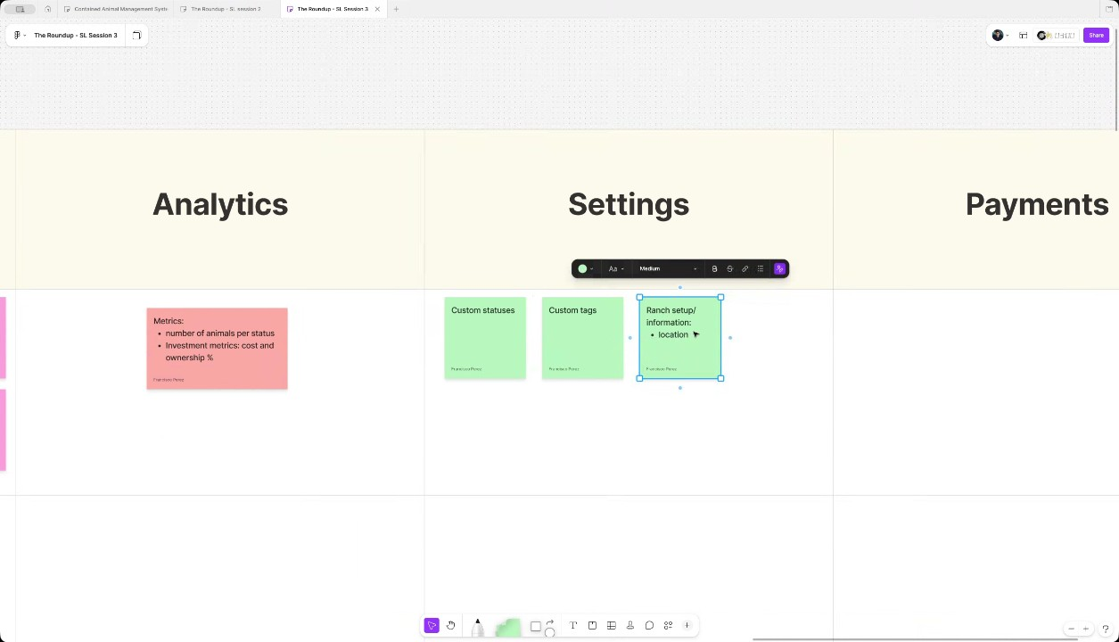
- Expense Tracking and Bulk Actions: Tracking expenses, such as vet bills, is necessary to facilitate calculations and split costs percentage-wise across partners, though this feature may be added later as a separate function (01:00:49). WyldSol clarified that users prefer to apply fees in bulk, such as charging a rate to 50 cows at once for shared resources like hay, confirming that most actions outside of individual video uploads are bulk operations (01:01:59).
- Minimum Viable Product (MVP) Settings Items: Francisco Perez determined that custom statuses, custom tags (including tag management), and locations are the most relevant items for the MVP settings (01:01:59). They noted that having the location setting readily available during the bulk upload activity would be beneficial for ease of use (01:03:01).
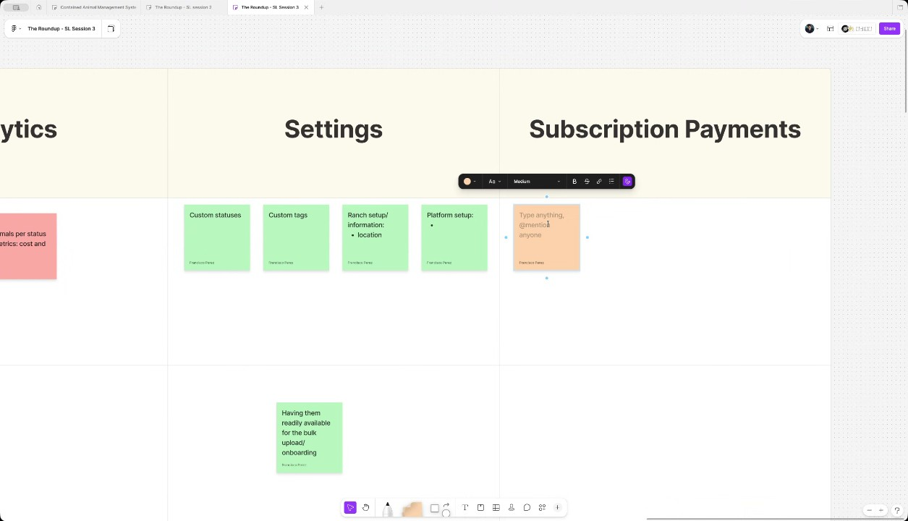
- Subscription Payment Methods and Tiers: The preferred payment method for subscriptions is standard credit card, despite users sometimes preferring other formats like AC for larger payments (01:03:01). Subscription tiers will be primarily differentiated by the animal headcount in inventory. The only feature differentiator noted is that partners who are not ranchers will have a read-only account, limiting their ability to add media or other content (01:04:17).
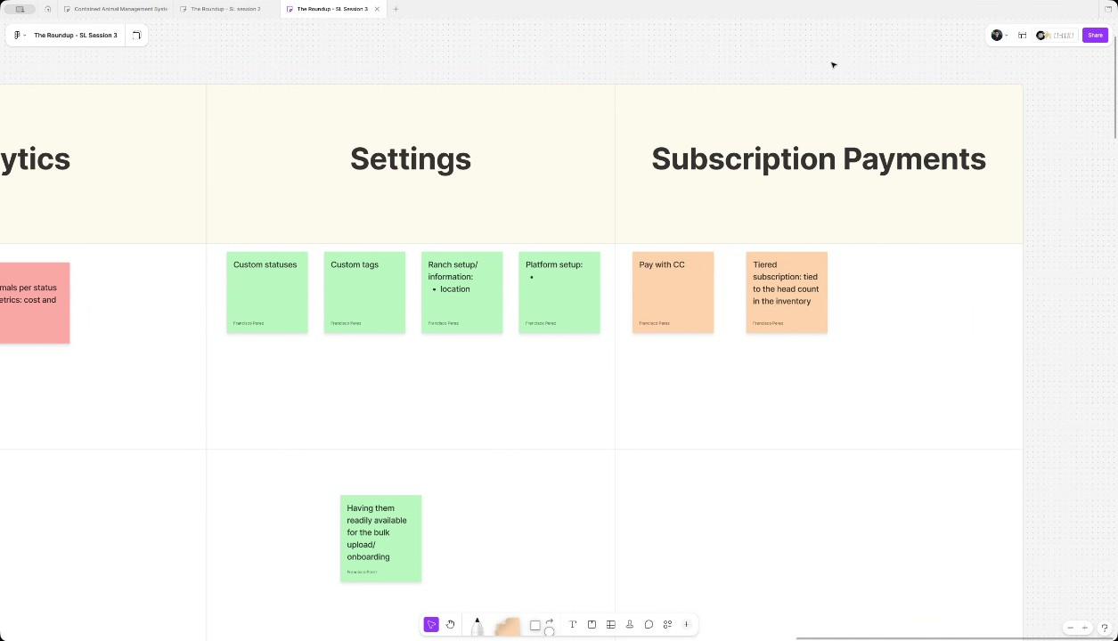
- Management of Media Storage Limits: The team discussed the need to address media storage limits, as picture and video uploads can grow quickly (01:04:17). Claudiu Constantin suggested they could compare with other storage services to offer a competitive solution and potentially offer add-ons for extra storage capacity, similar to how animal head count is managed. Francisco Perez agreed that this does not need to be decided immediately and can be adjusted later (01:05:28).
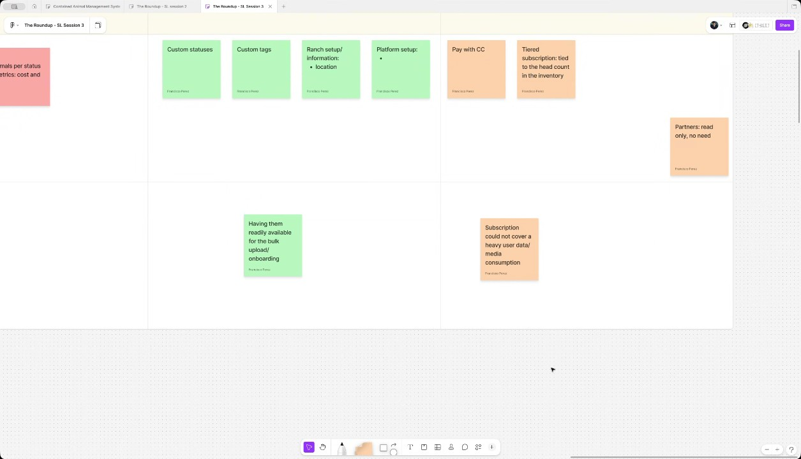
- Conclusion and Next Steps: The meeting successfully established the necessary information for the main MVP flows, which will feed into the design review and the final prioritization exercise. Francisco Perez offered to share the link to the board and invited participants to share any further information via Basecamp (01:06:32).
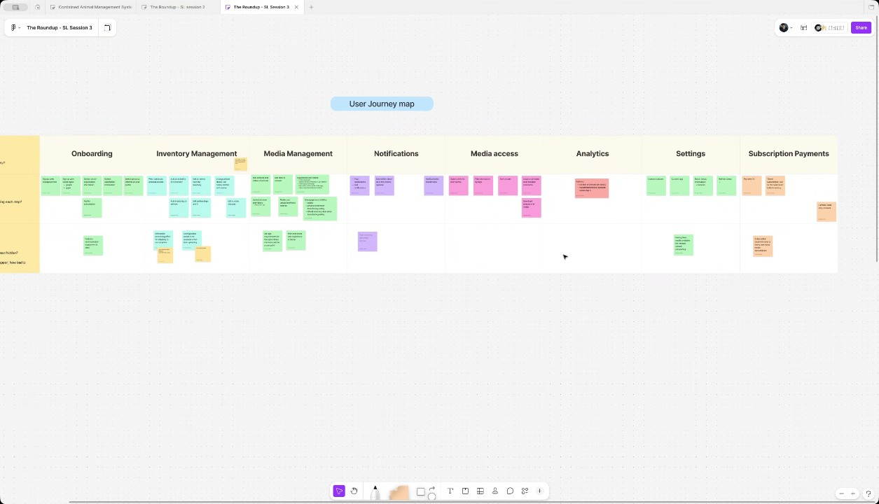

You should review Gemini's notes to make sure they're accurate. Get tips and learn how Gemini takes notes
How is the quality of these specific notes? Take a short survey to let us know your feedback, including how helpful the notes were for your needs.

📖 Transcript
Apr 29, 2026

Contained Animal Management System | Solution Lab 3 - Transcript

00:00:00

Francisco Perez: Right. So um previously on the on the second session and well in the review the first review we focused on kind of like the big picture just to establish the the the general overview of the product. On our second workshop, we double clicked a little bit more on the on the MVP, but today we want to focus mostly on the MVP flows to give Cloud enough information for him to focus on those uh designs in in a let's say a higher fidelity level, right? So, this is the the the exercise we're going to be doing today.
WyldSol: Okay.
Francisco Perez: We call it a user journey map. The idea is that we have this table that is uh populated with all of the user steps that uh let's say a typical user would go through in the application. Uh so we want to review those first as part of the MVP flows. And then we want to map two main things. First the user actions which are all of the individual features that make up each one of the steps or stages in the flow.

00:00:59

Francisco Perez: But at the same time, we want to think about some potential pain points or anything that we need to be on the lookout for when designing and implementing these features. Right? So, uh let's begin with this exercise and let's first review the user steps. So, just line let's just line on if this list is is comprehensive enough or we are missing something here. So first we have the on boarding of the user itself and the first thing we figure they they would like to do is the cows and bulls management. Um inventory management
WyldSol: Can we call that inventory?
Francisco Perez: right okay inventory management.
WyldSol: Yeah.
Francisco Perez: Uh the other thing is once they are set up this would be kind of like a setup part of the of the of the experience. After that the day-to-day activity would be for the MEP media management and with that media management comes some other flows. So notifications for everyone involved and the media access uh for the ones that have only read only access to it. Uh and then we have two different kind of like complimentary flows supplementary flows versus analytics.

00:02:07

Francisco Perez: So we want to explore what we want to show there. And last but not least, something we didn't discuss yet. Uh we talked about it in the first session but not so much on on the next ones which is the payment. So how they're going to be paying for the service. Uh not only the model but also uh what are the channels we intend them to use. So let me just begin here and ask you if you think this is enough information for the MVP flows or do you think we are missing any crucial step here?
WyldSol: No, that's all those screens that I had too. So
Francisco Perez: Okay. Awesome. Right. So, let's
WyldSol: well uh is onboarding are the settings in
Francisco Perez: Yeah. Oh, the setting the settings was the the flows you mentioned,
WyldSol: onboarding.
Francisco Perez: right? The the the the features of configuring uh if I recall correctly,
WyldSol: Yeah.
Francisco Perez: I think it was right.
WyldSol: So that's was where they had the animal status,

00:03:04

Francisco Perez: Yeah.
WyldSol: the location.
Francisco Perez: the status the meta data for for all of it. Yeah,
WyldSol: Yeah.
Francisco Perez: I think we maybe maybe we can add add that later because I don't see that happening as part of the on boarding experience, right? Uh I think it's going to be okay.
WyldSol: Yeah.
Francisco Perez: Let's go settings. Okay. All right. Uh yeah. Do you think this is with the settings this is enough um in terms of the steps?
WyldSol: Yeah.
Francisco Perez: Okay.
WyldSol: Yeah.
Francisco Perez: All right. So let's go ahead and see uh what do we have here. U so first uh the on boarding is the flow that we do have uh some information on in terms of the the designs and the UI. Uh maybe something I wanted to ask here is uh for the MVP do you think that we should offer social login? Uh I know that this for for for the app store and everything is is crucial but uh how much of a focus do you think this should have or do you think you know password is is enough maybe for just the first

00:04:08

WyldSol: I think email password is enough for the first round.
Francisco Perez: round?
WyldSol: Then we can get feedback. Most of our users honestly are on Facebook which is kind of weird
Francisco Perez: Oh, okay.
WyldSol: but
Francisco Perez: Facebook. Do you think Facebook is is is then a a good investment of effort in terms of social login compared to maybe something like Apple and Google or the core user base we want to tackle?
WyldSol: No. Yeah, let's just go with that.
Francisco Perez: Okay.
WyldSol: I'll put it on my list.
Claudiu Constantin: I'm I'm guessing they all have emails anyway, right?
Francisco Perez: Yeah.
WyldSol: Yeah.
Claudiu Constantin: To some extent. So, and it's probably going to be Google or Yahoo,
Francisco Perez: That is
WyldSol: Yeah.
Francisco Perez: Google.
Claudiu Constantin: but I'm not 100% sure that Yahoo actually has a social logining type of things. So, it's probably just Google.
Francisco Perez: I think they do but I don't know how how common really that is.
Claudiu Constantin: Never saw it like
Francisco Perez: Yeah,
WyldSol: Yeah, I haven't
Claudiu Constantin: ever.
WyldSol: either.
Francisco Perez: that is true.

00:05:08

Francisco Perez: Okay. And uh the other thing that you know the on boarding uh has for now is the setup of the let's say the general information and profile right so gather
WyldSol: Awesome.
Francisco Perez: personal information and profile
Claudiu Constantin: I also have some questions here in this area besides gathering personal information. It's more about on boarding each type of um role let's say for the platform which could be a rancher/trainer a bull owner and then a partner/investor and in the on boarding we kind of need to
WyldSol: Mhm.
Claudiu Constantin: establish how this happens so that someone needs to pay for the subscription as well as the main account right so I'm suggest I'm I'm assuming right now they sign up and as we have in the
WyldSol: Right.
Claudiu Constantin: wireframes they select their rancher SL trainer, bull owner or a partner investor. If they select a rancher/trainer, that means they will own the account and they will be able to invite bull owners or partners so they can participate in their uh inventory. Correct.
WyldSol: Yeah. Yeah.
Claudiu Constantin: So that means he will be the sole opayer of that account.

00:06:26

Claudiu Constantin: Uh which has subsequent limits to how many inventory you can have, pictures and so on. I'm I'm assuming we're
WyldSol: So he'll be the he'd be the owner of his account.
Claudiu Constantin: Yeah.
WyldSol: If he invites somebody, they have to go through the same process of deciding who they want to
Claudiu Constantin: Okay. But uh All right.
WyldSol: be.
Claudiu Constantin: But the in invitees they won't have to pay anything. Uh so they they will just join the portal under this umbrella that the rancher
WyldSol: No,
Claudiu Constantin: created and so they will have to pay as
WyldSol: they'll have to pay. Yep.
Claudiu Constantin: well. And that means they will have their own limits but they just sync their inventory together if they have a percentage into the specific animal or what what it might
WyldSol: Right.
Claudiu Constantin: be.
WyldSol: So the idea is if they are listed as a partner on an animal um then they automatically would see that animal listed into their um inventory but they wouldn't be the owner of it. The owner would be the person that entered it.

00:07:37

Claudiu Constantin: Okay. Correct. And then they establish. All right. So then that means we need some kind of invitation basis uh on back and forth either through email or specific ID or I know I'll see when I reach that point. I'll try to make it easy.
WyldSol: I did put a flow I put a flow in yesterday for that because I thought of the same
Claudiu Constantin: So that all of these so
WyldSol: thing the different places where I thought that would show up.
Claudiu Constantin: yeah okay perfect then I will I will uh
WyldSol: So
Claudiu Constantin: perfect because this was the area I wasn't 100% sure uh just because of the subscription uh relationship so I just wanted to confirm this loop. Okay, thank you.
WyldSol: Yes.
Francisco Perez: Okay. uh I took a look at the flow of the wireframes and I think that in order what happens is uh first you set up the ranch for organization information then you gather some of the stakeholder kind of like the split of how at the moment in at least in the in the in the wireframes flow uh you know how how how the payments go and after that you gather some personal information and also the the first animal.

00:08:46

Francisco Perez: So maybe my question is, do you think the importing makes sense like that? Or maybe you want to skip this stakeholder information, maybe just send invites to the people that are going to be part of your branch or organization or your tenant.
WyldSol: So so the one thing we're so I think we probably want to leave it here but I see Cladio now that I'm looking at the wireframes I see what you're what we're both getting hung up on. So you have pick a plan. So you're thinking the role is different than the plan
Claudiu Constantin: Uh Yeah,
WyldSol: and I Yeah. And I'm putting those together.
Claudiu Constantin: because
WyldSol: So you can be anybody you want. Um you're just a user of the system and your plan dictates um what level you get. So your plan is the tier and then you are just a person
Claudiu Constantin: Yeah.
WyldSol: right unless you're unless you're a partner then you're a
Claudiu Constantin: Yeah. So, uh
WyldSol: um read
Claudiu Constantin: yeah. So,
WyldSol: only
Claudiu Constantin: basically these are not roles that you select in the beginning.

00:10:05

Claudiu Constantin: So rather everyone has the same ownership of his account which makes sense because it ties in with the subscription. Uh but then you would need to invite other accounts/ people and you give them these roles based on their relationship with yourself or the animals. And that's when the role per account comes in because they they technically join the owner's account, let's say, but not in a per se way, but they they're sharing animals in that
WyldSol: Yeah.
Claudiu Constantin: way.
Francisco Perez: kind of like regarding hierarchy, right?
Claudiu Constantin: Yeah,
Francisco Perez: Uh,
WyldSol: Yeah.
Claudiu Constantin: exactly.
Francisco Perez: are they kind of like personal equals when you create the ranch and you manage the inventory or are you the the the first one and the other ones are kind of like uh just part of your organization but no no no first party let's say first first
Claudiu Constantin: Everyone is their
Francisco Perez: city first class citizens
Claudiu Constantin: technically everyone is their own owner in their own platform and whoever he invites then assumes the next roles that could be available which is bull owner or partner investor or whatever it might

00:11:12

WyldSol: Yeah.
Claudiu Constantin: be.
WyldSol: Yeah. So, what I'll do is I'll do a flow for each ro and slash tier of payment because they are kind of the same. So, I'll I'll do that today.
Claudiu Constantin: Okay. Now,
Francisco Perez: Okay.
Claudiu Constantin: now it makes um it simplifies the logic a bit
WyldSol: Yeah, I just
Claudiu Constantin: more.
WyldSol: sc
Claudiu Constantin: It's basically how Figma works.
Francisco Perez: Okay.
Claudiu Constantin: Everyone creates an account and then you invite a seat and you pay for the seat. But here you everyone pays the same fee
Francisco Perez: Yeah,
Claudiu Constantin: anyway.
Francisco Perez: that's a really designer way of looking at it, but I guess it makes sense.
Claudiu Constantin: Yeah.
Francisco Perez: Okay.
Claudiu Constantin: Okay. This is was the area that I had that I needed really some information, some extra information.
Francisco Perez: Okay, maybe at this point it makes sense to think about some potential pain points or friction points. So basically what we discuss here is if there is there anything that we believe is worth you know keeping an eye on maybe dropouts in the in the on boarding because of specific reason.

00:12:28

Francisco Perez: I think that at least the wireframes seems simple enough. I don't see any potential risk here, but I want to hear you if you think of
WyldSol: Yeah, I don't see any pain points here. Um, the only thing I can think of is and you have skip on those cloud. um is I don't want to have to put in an animal because most of these people um this isn't their first time. They've got an entire inventory that they're going to come in and slam in, right? Adding an animal on the fly is something that'll be later when they go and buy it or something like that and you know they're at the farm and they're like, "Oh yeah, I want that one. I'm going to buy it. kind of thing. So, um, but you have skipped there. So, I don't see any pain
Claudiu Constantin: Uh yeah, actually what I'm going to do here is maybe um instead of add adding an animal
WyldSol: points.
Claudiu Constantin: uh one by one, maybe we can offer an import feature. I mean we already have that in the listing itself like when you reach the the dashboard but maybe it's worth having it here as a step as well so that they land on a cooler dashboard.

00:13:52

Claudiu Constantin: If not we can also skip it and add a guidance in the dashboard itself like step one hey let's add your you know fill out your ranch because you skipped those basic details. Let's say import your animals, import the investors if you have just like a to-do list to guide them
WyldSol: Yeah, I like
Claudiu Constantin: better
Francisco Perez: But maybe the other thing I was thinking of is when are we going to prompt users to pay
WyldSol: that.
Francisco Perez: for for the subscription or or the tier
Claudiu Constantin: on boarding. Uh I'm guessing we're asking for up front,
Francisco Perez: access?
Claudiu Constantin: right? No trial or stuff like that.
WyldSol: Yeah, either you're logging in logging in or you're going to create an account. If you create an account, then do you want one to 50,
Francisco Perez: Okay.
WyldSol: 51 to 200? Yeah. How big of an account do you
Francisco Perez: All right. I think then maybe that's the only potential um pain point. Uh I think that maybe maybe having it's it's it's not a painoint in the sense that uh it's something wrong with the product but rather that you know it's always a friction point with users when you uh request payments right at the beginning.

00:15:05

Francisco Perez: Um, I think we will just have to do a great job at communicating the features of the app so that they have no doubts when when when on boarding, right?
WyldSol: And this is all going to So are we talking about web here or
Francisco Perez: Um, uh, I think mostly mobile uh,
WyldSol: mobile?
Francisco Perez: but but it applies to both because in boarding can be done on both uh,
Claudiu Constantin: Okay.
Francisco Perez: both plat parts of the platform. Um, but I guess mobile is going to be the the main funnel for for these
Claudiu Constantin: Yeah.
Francisco Perez: accounts.
WyldSol: because yeah, that is a pain point. Um, and looking at that information on the mobile is kind of that's going to be hard for the different tiers and what you get and all that kind of thing. So, I'm wondering if the mobile app is something you just get into and you have to go to the web to purchase. Does that make
Francisco Perez: that could be an option but I think it will create I don't know working with workflow I think it maybe interrupting that

00:16:09

WyldSol: sense?
Francisco Perez: flow for user experience is not the best uh experience right may maybe because you you would be eager to continue with the on boarding and maybe uh if you got to open a new computer Now, something you got to do later, but I don't
WyldSol: Yeah,
Claudiu Constantin: Yeah,
WyldSol: let me
Claudiu Constantin: I would not derail the process, especially because even if they're on mobile,
WyldSol: see.
Claudiu Constantin: they won't change. Like it's probably not going to happen. So, we will show the pricing tiers on mobile for sure, but more in a one by one type of way, like in a slide. Imagine a carousel maybe in that sense where you maybe you don't
WyldSol: Okay.
Claudiu Constantin: scroll to see all of them because some some people might not.
WyldSol: Okay.
Claudiu Constantin: It's easier to just one tier per screen you show maybe just a bit to know there's more and you swipe to see all of them. You choose one and continue. That reduces a lot of friction. Uh maybe we can also leverage some other information like uh providing a way to show more details on a pricing tier just to see a breakdown of maybe differences.

00:17:24

Claudiu Constantin: And that's when maybe we can have a drawer pop up from the bottom to up and show like a table view of this is what you get for tier one, tier two, tier three, but with minimal info, right? So instead of bombarding them with pricing, monthly, yearly, whatever, we have two states. One with tiers with minimal listings and then one where we go in depth about comparison that will help them
WyldSol: Okay. Yeah.
Claudiu Constantin: decide.
WyldSol: And I think really the key indicator is um how many head of animal do you have?
Claudiu Constantin: Yeah. Yeah. Yeah,
WyldSol: So that could be like the first question or
Claudiu Constantin: I'm guessing that's yeah,
WyldSol: something.
Claudiu Constantin: that's probably the biggest one because they already know how many animals they have and if they want to use the app to
WyldSol: Mhm.
Claudiu Constantin: the full extent, then they will need to pick the right
WyldSol: Yeah.
Claudiu Constantin: option.
WyldSol: Yep. Okay.
Claudiu Constantin: We also might think of some features that maybe do are like side quests in a sense.

00:18:24

Claudiu Constantin: So maybe a easy way to imp to add your whole ranch, right? uh like something that could hook them with, oh, this is so easy to actually jump on and test. Because I'm thinking that if I try to start a new app,
WyldSol: Yeah.
Claudiu Constantin: the biggest friction point is it's like moving an accounting platform to another one. It's like, "Oh my god, how much back stuff do I need to do to actually move?" And in some situations,
WyldSol: Right.
Claudiu Constantin: if I don't have an easy way to transfer, I'm like, "You know what? I'm I'm not going to do it.
WyldSol: Yeah,
Claudiu Constantin: I'm just going to So,
WyldSol: 100%. Yep. Somebody do
Claudiu Constantin: that might be a key inflow."
WyldSol: that.
Francisco Perez: Okay.
Claudiu Constantin: Yeah.
Francisco Perez: All right. Yeah, I guess that that uh that's what we can do at the moment to account for that potential payment.
WyldSol: Yep.
Francisco Perez: Um Okay.
Claudiu Constantin: Okay.
Francisco Perez: Like I I'm not
Claudiu Constantin: Like I I I'm not sure if there's we even have a competitor that's actually doing all the things

00:19:18

Francisco Perez: sure.
Claudiu Constantin: that we do and maybe we also need to look into a way to see if we can transfer that data to our platform in an easy way. That's sometimes what happens if you know you have a bigger competitor and want to steal some clients from them.
WyldSol: Yeah, I haven't found one that um is for this, but um what I can do cuz I'll spread some questions
Claudiu Constantin: Maybe they have a way to manage their ranch in a Excel sheet or a CS CSV file.
WyldSol: around.
Claudiu Constantin: I don't know like any other format they're using as an in-house approach. Maybe that's a prior that we should also consider as an import feature.
WyldSol: It's definitely Excel.
Claudiu Constantin: So,
WyldSol: Excel and Google Forms or Google Sheets.
Claudiu Constantin: okay. So those should be prior on ease of use and transferring and maybe we should also
Francisco Perez: Thank
WyldSol: Yeah.
Francisco Perez: you.
Claudiu Constantin: guide them into how to set up certain columns or data so that we can easily digest them.
WyldSol: Yeah,
Claudiu Constantin: uh maybe even use AI.

00:20:22

WyldSol: like a template or
Claudiu Constantin: Yeah, depending on how they set it up because since it's not a standard and they probably use
WyldSol: something.
Claudiu Constantin: whatever personal criteria, uh we need a way to standardize that in a readable format so that we can actually import them.
WyldSol: Yeah.
Francisco Perez: Okay. All right. Uh let's move on to the next step which is the inventory management. We mentioned the adding the first bull skipable but I guess in this case once you're already into the platform itself uh I have a couple of questions here focusing mostly on the mobile flow I guess we don't really see at least I don't really see uh people doing like bulk uploads in the mobile flow right I guess it's going to be more of adding one extra bull one extra cow once you already do the dunk right so let's
WyldSol: Yeah.
Francisco Perez: say I have um bulk slashmass on board animals uh and the rest would be all mobile. So I guess the the normal activities right you can add an animal to the inventory.

00:21:35

Francisco Perez: Uh my my other question is how common it is to delete or edit an
WyldSol: Um, in the first part to edit them,
Francisco Perez: animal.
WyldSol: it's probably pretty standard. Um, we actually don't want to delete. We want to use the statuses. Um, and just go inactive because we are basically keeping the database of animals. Um, and they don't want to lose any of the media. So, that's a good point. I need to put together a flow of system statuses and then um I envision them being able to create their own statuses as well, but those are just kind of indicators. The system statuses are the ones that are going to programmatically do something in the system. So, I'll put together the um flow on that.
Francisco Perez: Okay. And the other question I have is regarding updates for competitions or like okay this edit or update animal from the inventory, right? Uh I think they have kind of multiple tiers of information. Uh so we have the the animal itself in terms of the name, the ids, any any identificators, identifiers sorry or any other information like that.

00:23:02

Francisco Perez: But I guess we also have uh you know the the addition of or tracking of different activities and some of them are not part of the MVP uh as we mentioned. But I don't know if there's anything as part of inventory management that you think is worth uh noting here that is not your typical okay yeah this bull is this age uh you know this is named like this and this is the identifier and everything. Uh is there anything regarding competitions or something like that that you want us you want to see here as part of the inventory management?
WyldSol: Um I mean there's so yeah I mean there's a lot of stuff but it's later so I don't know um in the inventory management you're going to have the partnerships right so that's a huge piece of
Francisco Perez: Oh, that's true. Yeah.
WyldSol: it um for MVP P. Um, I mean, I do want to get the events in, but I I think that's not MVP. Well, maybe it is MVP because that's a huge part of the media.
Francisco Perez: And
WyldSol: So, we probably do need to have events as

00:24:24

Francisco Perez: okay, maybe yeah, maybe not everything about the event, but at least to create them here in the in the event
WyldSol: Yeah. Yeah. Because that's one of the tags that we can put on this stuff, which is huge.
Francisco Perez: Okay. Yeah. At least as at least as as tax, right? Uh maybe the not not even their own entity like you can add information to it,
WyldSol: Mhm.
Francisco Perez: but at least you have it as as tax would be useful for the MVP.
WyldSol: Yep.
Francisco Perez: Okay. All right. uh in terms of the inventory management, I don't really think there's going to be that big of a friction point. Maybe the bulk or mass on boarding of animals is something that we would like to to take kind of like care of in terms of the user experience. Uh do you think there's going to be any any any work on their end? Like for example, I don't know if they they do manage these bulls in in spreadsheets. So maybe we could use a format or or or facilitate their lives so that they don't need to kind of like basically program their own uh uh information hierarchy so that they can on board them to the system.

00:25:38

WyldSol: I mean it would be nice cuz we onboarded and well when we get to settings we're going to say what are your locations you know like do you have an eastfield do you have a southwest ranch you know all those kind so that's their locations Then they have their types. So they have heers, cows, bulls. Um, and then they have like they've inciminated embryo embryos. They have embryos as well. Um, so they'll have those types and they'll have their statuses. And maybe it's worth when we do the bulk import. Um, we let them know. I mean, if you what I don't I don't Okay, so here's what I'm thinking. If they've set up different statuses, let's say in their settings area and then they go and try to bulk upload a thing where those statuses are different, I don't want to add those statuses in because that's kind of that's not what you set the system up as. And so I think that's a pain point that maybe during this bulk upload we say here's everything you told us in this template and go ahead and copy your bowl names and put them in here and use this temp I don't know you know does that make sense?

00:27:11

Christian Ruiz: Yeah, I Yeah, I think I think the easiest is what Claude just said maybe and what you just mentioned having a template and a standard dice template so that it so that it is easier for us to do the bulk imports but that would maybe that would require uh work from them if they because they would have the they had their Excel sheets and all these things and they have to adapt to our template kind of thing.
WyldSol: Mhm.
Christian Ruiz: So maybe we can have this I mean this is the easiest approach.
WyldSol: Okay.
Christian Ruiz: Maybe we can consider on a on a future uh maybe introducing some AI to extract this information. But this for the MVP I think having a template is the is the best way to
WyldSol: Yeah.
Christian Ruiz: go.
WyldSol: And I think that also gives them a little bit more when they have to actually put it together, it gives them a little bit more information about the tool. and how the information goes together. Kind of it's kind of self-training them on what's in
Francisco Perez: Yeah,

00:28:20

WyldSol: there.
Francisco Perez: I think that that's key uh for them to to get to know how how the platform is going to help them organize information. I guess, you know, we we can expect them to either have their own method already or simply be looking for one. And I guess we could offer one that really makes sense for them. Um, so I got these two pain points. One is the information processing effort. So they need to adapt to our template. That could be a potential friction point. And the other one is the configuration items need to be available when bulk uploaded, right? So that if you if you want to add 100 bolts with a custom status, then that needs to make sense right at the beginning instead of you having to to go to change that later just because you added a configuration,
WyldSol: So,
Francisco Perez: right?
WyldSol: do you think that's a wizard when they onboard?
Francisco Perez: Could be.
WyldSol: board because you necessarily need
Francisco Perez: Yeah, I think I think you're right.

00:29:11

Francisco Perez: Could be could be more than simply one one single step, right?
WyldSol: it.
Claudiu Constantin: Yeah, it could be a guided wizard to be honest. Uh, which is capable in the on boarding so that if they don't have what they need,
Francisco Perez: Uh
Claudiu Constantin: they we can still allow them to sign up, you know, and explore the platform since they paid and we don't want to glo them there and they have the to-do list on the dashboard which they can do whenever they want to or have time. uh we just need to make sure that we include some of the edge cases
WyldSol: Yeah.
Claudiu Constantin: that we have platform wise which is for example who's training who uh who is an investor or a specific list of the bulls they already have in
WyldSol: Heat.
Claudiu Constantin: their Excel sheet because let's say they add a thousand bulls or 100 whatever they still need to manually go through each of them by name if they know or search or do a type of multi select to assign everything properly so that the platform actually works the way it's intended

00:30:14

WyldSol: Yeah.
Claudiu Constantin: because technically they're not going to be a single person. There's going to be a bunch of people involved.
WyldSol: Yes.
Claudiu Constantin: There's going to be some invites needing to be sent uh while they do the import which
WyldSol: Yep.
Claudiu Constantin: can should be technically part of the last step of the wizard like okay we imported your bulls we imported this. imported this maybe we detected an issue here some conflicts like random statuses or I don't know mistakes in general so we need to give a summary of some sort so they can
WyldSol: Yeah.
Claudiu Constantin: manually update maybe uh afterwards and maybe
WyldSol: Yeah.
Claudiu Constantin: we also give them a list of people they need to invite so that they so we can assign them to the animals listed. So, hey, we detected these people that are investors to this uh trainers to this and so on. And you're like, okay, do you accept? Do you confirm? Send invites, add emails, maybe, I don't know, send invites. And they when they join the platform, they already get assigned those specific list of animals by default.

00:31:16

Claudiu Constantin: And if there's a situation where they try to import their animals, we need to make sure we don't find duplicates because then that's going to be another bummer. So, uh,
WyldSol: Yeah.
Claudiu Constantin: and I think that's the extent of importing, uh, and making sure we don't have loose ends.
WyldSol: Yeah, duplicates are going to be huge.
Claudiu Constantin: Yeah. And we need to detect and know, hey, this belongs to someone that's already on our platform. Is he the owner or are you the owner?
WyldSol: Yeah.
Claudiu Constantin: So, there are some edge cases here that might happen. Not sure if we're going to cover everything. I hope I catch on them all,
WyldSol: Yeah.
Claudiu Constantin: but just to be aware of what might what risks we have in this
WyldSol: That's a good point. Um,
Claudiu Constantin: area.
WyldSol: and I don't know if we go from the partnerships if we say the person who has the most percentage is the owner or if we get an give an option to identify the owner because what the owner does in the system is they have the ability to edit the animal.

00:32:20

WyldSol: What the other guys have in the system is you don't get to edit the animal. I mean, you may be able to leave a comment to say, "Hey, I think we should change this," but you can't edit him unless you're the owner.
Claudiu Constantin: Yeah.
WyldSol: So, I'm not sure how if that's best to go from the percentage or a selection.
Francisco Perez: Yeah, I don't know if it makes sense for the you know to to to maybe use the the term handler or something like that for the editing um options. I don't know if there's a scenario as you mentioned where for example one of the stakeholders is the the main owner but maybe they're not the one that are the more involved in with the animal right?
WyldSol: Yeah. Yeah. And handler is a term they use,
Francisco Perez: Yeah.
WyldSol: but I don't know if that would always be the the guy that um Yeah.
Francisco Perez: Yeah.
WyldSol: I will find out.
Francisco Perez: Okay.
Claudiu Constantin: importing might need a bit more work than expected based on these criterias.
WyldSol: Mhm.
Francisco Perez: Okay.

00:33:32

Francisco Perez: I just added the comment to to wait for that confirmation and yep. Okay. Uh let's move on then to the media management uh features. So um for media management. Uh what we discussed so far is the the ability to add pictures and videos. Right. That's the media formats we're going to support. Okay.
Claudiu Constantin: I think we also have links.
WyldSol: and links. Yeah.
Francisco Perez: And links. Yeah.
Claudiu Constantin: Yeah. Uh yeah.
WyldSol: Yep.
Claudiu Constantin: Yeah. Where you can add basically a custom link to whatever and give it a name.
Francisco Perez: add links to animals and I guess well instead of add let's I'm going to use the word take pictures and videos of the animals because that's the the main flow we want to we want to uh facilitate to them right instead of them having to add them later and and and organize them manually just let them open the animal and take a picture and I guess adding would be uh well the links they can just be added but I guess the other thing I wanted to focus today is in terms of the tagging part we have discussed a little bit about it but uh I don't know if you can explain to us how that works

00:34:48

WyldSol: So if I take the picture, um the the happy path flow would be I from the inventory I go into the animal and I hit take a picture or take a video and I already know it's that animal. um you know he's 6 years old whatever all you know all the things that I know from the profile of the animal and so those become like autolin just metadata for the animal that's the happy path the not happy path is I'm sitting on my media thing and I hit take a photo and now I don't know what animal that is and I think during the save it is you need to tag it with something, right? Or it's going to be untagged. I noticed you had an untagged, which is perfect. Um, but even the untagged should have some kind of metadata like a date or some, you know, something that I can figure out what I was doing. Um, and then there's always the, "Hey, I had a picture. I didn't add a tag. I want to add another tag scenario or I want to edit tags.

00:36:12

Francisco Perez: Okay. And these tags we discussed for example them being events. Uh what other tags do you think normally we would see here?
WyldSol: Um, you would see the name of the animal for sure. Um, the date. Um the age I think would be a big one. Um
Claudiu Constantin: They can also add custom tags. They can also add custom tags. So, they'll probably add whatever they think on the spot, which makes
WyldSol: and the brand ID. Yeah,
Claudiu Constantin: sense.
Francisco Perez: It's okay.
WyldSol: because they can have they can have an animal that never has a name.
Francisco Perez: Right.
WyldSol: Um, but it will always have that brand
Francisco Perez: Okay.
WyldSol: ID. One other flow we didn't add in is they've been doing it a long time and all of them have folders, hundreds of folders worth of pictures and videos on their phone that they're going to want to bring in.
Francisco Perez: I guess the flow then would be upload and target, right? Okay.
WyldSol: Yeah.
Claudiu Constantin: Yeah, I guess we can allow single or multi select if it's from a photo library.

00:37:48

Claudiu Constantin: So add media and then if you on your phone, you select phone library. If you know your animals, then you can select multiple of the same and then you know apply the right tags.
WyldSol: Yeah. Yeah.
Claudiu Constantin: It's
WyldSol: They have them all in folders by the names and are they brand IDs.
Claudiu Constantin: also
WyldSol: So
Claudiu Constantin: it's also up to them to manage their database cleanly.
Francisco Perez: Okay.
Claudiu Constantin: let's say because if you put crap in then that we
WyldSol: yes,
Francisco Perez: Yeah.
WyldSol: 100%.
Claudiu Constantin: we cannot give correct data. Um but you raised a question about some of them not having names and in the flow I actually made the animal name mandatory and it's also the biggest info that you see on the table. Should we maybe switch that around and show the ID and then the animal?
WyldSol: Yes. A brand. Mhm.
Claudiu Constantin: Yeah, unfortunate,
WyldSol: Yeah.
Claudiu Constantin: but okay.
WyldSol: I know.
Claudiu Constantin: Uh,
WyldSol: I know.
Claudiu Constantin: I'm gonna leave a comment for myself here.
WyldSol: I don't want to waste the

00:38:56

Francisco Perez: Okay.
WyldSol: names.
Claudiu Constantin: Yeah. Okay. So, brand ID is actually the leading uh criteria
WyldSol: Mhm.
Claudiu Constantin: here.
WyldSol: And it will that brand ID will be the same as long as that cow lives. Even if I branded it and you bought it, you keep my brand number.
Claudiu Constantin: Okay, I see.
WyldSol: Yeah.
Claudiu Constantin: Okay, the name comes secondary. Basically, we're just switching places in the table view right now.
WyldSol: Yep.
Francisco Perez: Okay, the other thing I wanted to to ask for this specific flow uh is the what we mentioned about having no coverage in some areas or maybe uh trying to circumvent the need of a of a of a a background upload uh or or sync later feature. uh in favor of a background upload. So uh maybe the question is for the MVP um from what we know also this is for you Christian too. Uh do you think we can settle on the on the the WhatsApp slash uh I know what other app does that. I think that maybe a couple of of other uh text synaps

00:40:05

Claudiu Constantin: All
Francisco Perez: uh um approach of sending media that maybe when something is something is too too too heavy or or something like that it does in in the
Claudiu Constantin: right.
Francisco Perez: background.
Christian Ruiz: also the offline thing that that we mentioned in the
Francisco Perez: Yeah.
Christian Ruiz: retry for the
Francisco Perez: The retries. Yeah. Exactly. Or the Yeah.
Christian Ruiz: MVP.
Francisco Perez: or or and this is also a question regarding product because I don't know if that's really a scenario we want to cover for the MVP or maybe that's something we build as as an improvement later or if it's really crucial for the user experience at the beginning uh we can prioritize
WyldSol: I think it's crucial for the experience in the beginning because the first video they or they get stopped. Um, they're not going to use the tool. Yeah, that that's that's their whole existence are these
Christian Ruiz: All right.
WyldSol: videos.
Claudiu Constantin: Okay. Can we leverage local storage on this?
Christian Ruiz: Mhm.
Claudiu Constantin: And whenever they have the internet, we we load it back in the background.

00:41:17

Claudiu Constantin: So, cuz I could add like a status area in the notification part, right? or maybe even in the specific area they're uploading. And if we detect that it doesn't work, we shelf it there. We show it as you need internet for this to continue or just some status and they're aware of the situation. Data is saved technically because they already took the pictures.
WyldSol: Yeah.
Claudiu Constantin: I'm just wondering if we can actually save the data they're adding to them like tags and whatnot.
WyldSol: Oh
Christian Ruiz: Yeah, I think the method we use for do the retry I could could I mean could
WyldSol: yeah.
Christian Ruiz: change could vary but the thing we need to do is to be able to store the video somehow so do not so we don't lose the the media uh then the way we do for try to re-upload this could change and I'm going to be I'm going
Claudiu Constantin: Yeah.
Christian Ruiz: to be doing some research on on how what would be the best way but yeah the important thing is not losing the

00:42:22

Claudiu Constantin: Yeah.
Christian Ruiz: Yeah.
Claudiu Constantin: So leveraging local data somehow because if they take pictures in the app or the video for that matter that still gets saved in the photos library right on the phone but I'm
Christian Ruiz: Heat.
Claudiu Constantin: not sure. Yeah. Okay. We need to check but besides that we also need to keep an account what type of data they actually add and edit.
WyldSol: Yeah, cuz if it gets saved on the phone, that's their choice, right? We've got to give them a choice on the app whether they want to allow that or
Christian Ruiz: Yeah, we always I think apps should ask you if they can access to your storage.
WyldSol: not.
Christian Ruiz: I think that's the way they do it.
WyldSol: Yeah. And if they tell us no,
Claudiu Constantin: Yeah.
WyldSol: then do we need to tell them some I mean Yeah. So that could be a pain point.
Francisco Perez: Okay. Yeah.
Claudiu Constantin: Good to keep in mind though.
Francisco Perez: The other thing that that could be a pain point is getting users to take pictures with the app.

00:43:42

Francisco Perez: I think that's that's something that we really need to make really simple, right? I guess uh based on the on the users that you have described, uh I guess they just want a really point and shoot user experience, right? Uh open the animal and open the camera interface and take a picture. That's it.
WyldSol: Yeah.
Francisco Perez: Yeah. Okay.
WyldSol: Yeah,
Francisco Perez: Yeah.
WyldSol: open the animal point for
Francisco Perez: Okay.
WyldSol: sure.
Francisco Perez: Okay.
WyldSol: Um, the other thing they're going to do, and I don't know if you follow that in or if you put that in the tags, but it's the public private, which is um a big thing because if it's private,
Francisco Perez: This is
WyldSol: not even the partner can see it.
Francisco Perez: okay. So public would be everyone can see it in that it's a stakeholder or owner in the cow bull right and private is only for the uploader which is the
WyldSol: Yeah.
Francisco Perez: the the owner the sole owner right
WyldSol: Yep. And if I sell that and I'm not the owner at all,

00:44:51

Francisco Perez: okay
WyldSol: um those private ones will always stay with me and the person I sold it to gets the public ones. Um so there is kind of a um a
Francisco Perez: Okay.
WyldSol: ghost um inventory item. It's kind of like a snapshot. If I sell them, I always want to keep that because what they do is, you know, let's say he was a big huge winner, they're still gonna want to use that media that they have on him in future brochures and sell items because that tells everybody that they're a really good trainer.
Francisco Perez: Yes, it's as more more in terms of branch/services than the animal itself, right?
WyldSol: Mhm.
Francisco Perez: Nice. Yep.
WyldSol: Um,
Francisco Perez: Okay.
WyldSol: and then the on the media the filtering. I don't know if you need to put that there, but
Francisco Perez: Oh, yeah.
WyldSol: that's
Francisco Perez: Uh but I guess uh maybe that's more in terms of media access I guess like
WyldSol: Oh, yeah. Yeah.
Francisco Perez: okay yeah all right uh then notifications I think notifications
WyldSol: Yep.
Francisco Perez: is is really important even if it's going to be simple at the beginning uh we mentioned uh push text emails so I don't know if we we made a decision on the channels already

00:46:20

WyldSol: I think we went push and text because we want to use the contact
Francisco Perez: Okay. Yeah.
WyldSol: list.
Francisco Perez: Push and text. And uh my question here would be also notifications are mostly for the the um the partners, right? So here my question is do we want to give them the control of what they get notified about or do we want to treat it more kind of like a broadcast and they should be subscribed to everything?
WyldSol: I think it's a broadcast and they should be subscribed to everything cuz these people aren't just going to go out and
Francisco Perez: Okay.
WyldSol: spam um these things out because they're kind of coveted, you know. Um the one thing is is this notification um also pertaining to the notification invites and things like that or is this just notification of
Francisco Perez: I was thinking more in terms of the media because of the feature itself,
WyldSol: media?
Francisco Perez: but I guess it makes sense in terms of as a globally, right? So I get the the invites would be email mostly, right?

00:47:28

WyldSol: Yeah. Yep.
Francisco Perez: Yeah.
WyldSol: That's what I was going to bring up. I mean, I guess it would be nice to have an an invite notification via text and when they do that, then they come to the onboarding. Here's the tool screen. I don't I don't know what that screen is, though. Um, yet that's the one we talked about before. So,
Claudiu Constantin: We can also customize the invites based on what the user wants to do. Like if if on desktop, yeah, sure, they enter their email or maybe phone number if you want to, but I think it's email is easier and we send it. But if they're on their phones, we can provide a custom invite which then they can use their social share uh sheet on the phone and they can send a custom invite based on WhatsApp messenger,
WyldSol: Okay. Yeah.
Claudiu Constantin: SMS,
WyldSol: Okay.
Claudiu Constantin: select a person from his contacts,
WyldSol: Yeah.
Claudiu Constantin: etc.
WyldSol: Yeah. That would be super easy for him. They use that a lot. So
Francisco Perez: Okay.

00:48:39

Claudiu Constantin: It's a feature built in the phone. We're we're just leveraging that
WyldSol: yeah,
Francisco Perez: Right.
WyldSol: I like those features.
Francisco Perez: Okay. Uh I guess for notifications uh the only thing that I can think of in terms of pain point is you know the well I guess because we have push and text we shouldn't have that much of an issue but I guess maybe not having that timely uh notification because of any any any issue like the permissions there could be some friction there but I don't think that's anything there there's anything actionable from our end solving that Right. So I really can't think of any any potential friction point
WyldSol: No. Uh well, and I noticed I can't I don't know where it's at right now,
Francisco Perez: here.
WyldSol: but I noticed um you created um a list of um partners. Um and you had a status on them that they were invited or I forget where that is.
Claudiu Constantin: Yeah, let me quickly check.
WyldSol: Oh, yeah,
Claudiu Constantin: It was on the settings somewhere.
WyldSol: there it is.

00:49:50

Claudiu Constantin: Uh,
WyldSol: Yeah, users enrolled,
Claudiu Constantin: so user roles.
WyldSol: I think.
Claudiu Constantin: Yeah,
WyldSol: Yep. So,
Claudiu Constantin: exactly.
WyldSol: I was hoping maybe that users and roles um could be a partners' list um because we don't have the roles anymore, but a partners' list that says you invited them and um and if the person but they're still on my partner list and they still fill up my I can use them as my drop downs even if they haven't accepted, right? because they are still a a partner for me. Um, but if they do accept, then that invite goes away. So, I I do like that. I wanted to use that. Oh, you called it a partners' directory. Oh, I'm on the wrong sheet. Perfect. Yes, that partners directory.
Claudiu Constantin: Yeah.
WyldSol: You're already ahead of
Claudiu Constantin: So,
WyldSol: me.
Claudiu Constantin: so this is actually what uh we have. This is more of a internal management let's say with this you roles right where you can click based on the
WyldSol: Yeah.
Claudiu Constantin: roles you're setting up here which are the roles when you on board basically we're not allowing custom roles

00:51:08

WyldSol: Yeah. Yep.
Claudiu Constantin: it's just transparency between what each role can
WyldSol: Yeah. Yeah. So, I'll go through that and comment when I get you the flow
Claudiu Constantin: But these two will be merged to be honest.
WyldSol: workflows.
Claudiu Constantin: Uh because things changed a bit since we now from our first
WyldSol: Yeah.
Claudiu Constantin: discussion on boarding not certain roles aren't applicable.
WyldSol: Yeah.
Claudiu Constantin: So we will merge these two into one called partners directory.
WyldSol: Okay,
Claudiu Constantin: And that's
WyldSol: perfect. I love
Francisco Perez: Okay.
Claudiu Constantin: it.
WyldSol: it.
Francisco Perez: All right. Uh let's move on to the media access features. So for the media access I guess the the main thing here would be uh what you can do to browse the media better. So uh we do have in the wireframes at the moment uh a kind of like a gallery view for for each animal right.
WyldSol: Mhm.
Francisco Perez: Uh you mentioned that we would be able to filter and even maybe search for them. I guess these would be related to tags mostly right.

00:52:23

WyldSol: Yeah.
Francisco Perez: Okay. And uh I guess the other useful thing would be to sort these media files and links by date maybe. Yeah, I guess date
WyldSol: Yeah. Most
Francisco Perez: is.
WyldSol: recent
Francisco Perez: All right. Um and we mentioned a couple other interactions. So leaving a comment and I guess liking would be maybe maybe liking or saving is something we we discuss and you mentioned that that was not needed, right?
WyldSol: um liking them is not needed. The thread comment thing is needed. Um but the um download they should be able to download and save them.
Francisco Perez: Okay.
Claudiu Constantin: I have a question here regarding comments. uh and reading.
Francisco Perez: Yep.
Claudiu Constantin: So let's imagine it's using some social media setup, right? Uh in that sense, but without reacting emojis or anywhere. Uh but they won't be able to click on the name itself to see some kind of profile. Correct? Because we haven't really tackled this area of social aspect, let's say. Um, so it's just going to be a comment with maybe a picture and the name and the status of that person, maybe partner, owner, whatever, whatever the relationship might be within the owner's platform.

00:54:03

Claudiu Constantin: Correct? So for example, if I'm the rancher, I have a picture and my partner comes into my picture and leaves a comment, then I will see his picture name and the tag of partner. But if I comment on his picture because he's an owner of that picture, then I will be showing as a partner to him.
WyldSol: I don't I don't think we need to give the role at all. I think it's just the date and the name.
Claudiu Constantin: Yeah. Okay.
WyldSol: Yeah.
Francisco Perez: Okay.
WyldSol: Which brings a point. I want to do that on the um animal profile as well. Have that thread comment ability.
Claudiu Constantin: I think I added a place but it's rather notes and should be actually comments that can be expanded.
Francisco Perez: Okay. All right. Uh yeah. In terms of any potential friction points for the media access, uh I guess maybe the only thing would be you know, the the the searching by tags and filtering because maybe the tags are not going to be created by the stakeholders, right?

00:55:35

Francisco Perez: If if they use custom tags for for organizing the media. So, I guess I don't know if we need any description of tags or do you think they're going to be self explanatory to most users?
WyldSol: It'll be self-explanatory.
Francisco Perez: Oh, okay.
WyldSol: Yeah.
Francisco Perez: Okay, then. Uh, yep. I guess that makes up media access, right? I don't know if there's anything here that you think we're missing.
Claudiu Constantin: Just more filters. I added a extra few, but that's about it. So,
WyldSol: Yeah.
Francisco Perez: Okay.
Claudiu Constantin: filtering by type.
WyldSol: I think the biggest pain point here is um easy to add and um easy to filter. Those are their two
Francisco Perez: Right. Okay.
WyldSol: things.
Francisco Perez: Then let's move on to the analytics ver MVP version. Right. So, uh we mentioned a couple of metrics that we maybe wanted to see here. Uh mostly I think we mentioned something regarding the number of bulls of animals.
WyldSol: Yeah, I think it was how many animals do I have um that are in

00:56:51

Francisco Perez: Right.
WyldSol: a different status? So, it's animal per status
Francisco Perez: Right.
WyldSol: um
Francisco Perez: maybe as part of the the stakeholders slash owner slash uh partners maybe something where in the investment do you think that's something they would like to
WyldSol: Yeah,
Francisco Perez: see
WyldSol: I think they're definitely going to want to see um how much they paid for them, like how much they cost when they bought them. And then when they hit sell, they're going to want to see how much they sold them for.
Francisco Perez: Right. Okay. So those are kind of like the the main metrics. Uh is there any other thing regarding analytics we would like to see in the MVP?
WyldSol: No, I don't think in the MVP. I'll double check, but um MVP is pretty simple.
Francisco Perez: Okay. All right. Do you have any questions here, Cloudy? Because I know that this was something we discussed only in the the previous um session.
Claudiu Constantin: analytics in the sense of what stats to show in the platform or something that we should gather as

00:58:14

Francisco Perez: Yeah. regarding the metrics or or the visualizations for it because you know it's pretty basic at this point.
Claudiu Constantin: a
Francisco Perez: But um
Claudiu Constantin: so what we have so far of course animal active in care upcoming
Francisco Perez: yeah
Claudiu Constantin: events, uh, invoicing status.
WyldSol: Yeah, invoices All
Claudiu Constantin: We also have, and then we have some stats broken down by competitions maybe,
WyldSol: right.
Claudiu Constantin: so events that you've participated, total winnings, average scores, uh, win rate if applicable, average, and per animal. Then we have more for financials but this is still in the invoicing area let's say uh reports which allows them to generate a bunch of reports based on whole data but it's still based on financials and competitions um and I think that's it as categories I would say um did I miss
Francisco Perez: Thanks.
WyldSol: Yeah.
Francisco Perez: Okay.
Claudiu Constantin: No. And also stats per animal, but that also falls into the competition area, I
WyldSol: Okay.
Francisco Perez: Yeah.
Claudiu Constantin: guess.
Francisco Perez: Yeah. The idea would be to build this uh once we have more more information and features, right?

00:59:42

Francisco Perez: Uh okay.
Claudiu Constantin: Yeah.
Francisco Perez: Now, let's then move on to the settings area. I think this is something that we uh also have mopped here. So, I guess the main thing we want to have is custom
WyldSol: Mhm.
Francisco Perez: statuses,
WyldSol: Mhm.
Francisco Perez: custom tags. I guess the tech management uh yeah apart from that the the the
WyldSol: Yep. Locations.
Francisco Perez: ranch setup kind of like information
WyldSol: Yeah. Yeah.
Francisco Perez: media.
WyldSol: The
Claudiu Constantin: Yeah.
Francisco Perez: Okay.
WyldSol: locations
Francisco Perez: What other things do you see here?
Claudiu Constantin: I also I also added a default settings area where you can
Francisco Perez: Yeah. Go ahead.
Claudiu Constantin: ask you can fill out daily care rates, currency, uh fiscal year start stuff like that which is more in accounting area but I'm not sure if it's I think it's needed because because otherwise you don't know how to split certain expenses. I'm not sure cuz once you invoice or maybe you add certain expenses from for a specific animal, I don't know, maybe it got hurt, vet bills, etc. We kind of need to keep track of them per animal and then split those

01:00:49

WyldSol: Yeah.
Claudiu Constantin: bills percentage- wise across partners and
WyldSol: Yeah,
Claudiu Constantin: whatnot.
WyldSol: that absolutely is what we want to do. But I don't know if we add um I don't know if we add those until we add the invoicing. I mean, it would be nice for them to capture it right now,
Claudiu Constantin: Yeah.
WyldSol: but they couldn't do anything with it until we got invoicing, right?
Claudiu Constantin: Yeah. I mean this is part of the invoicing process just to facilitate the calculations and what's happening.
Francisco Perez: Yeah.
Claudiu Constantin: And this part of the animal care is pro I don't think it is included right now.
WyldSol: Yeah.
Claudiu Constantin: So it's going to come up at a later date as a separate function. The same way you add media,
WyldSol: Yeah.
Francisco Perez: All right.
Claudiu Constantin: you can add expenses.
WyldSol: Yeah.
Claudiu Constantin: Let's
WyldSol: Yeah. Um, one thing on that, um,
Claudiu Constantin: say
WyldSol: just for the future, what the action, the happy path action they're going to take is they're going to go and pick, um, anywhere from one to 200 out of their inventory and they're going to apply a fee.

01:01:59

WyldSol: They're not going to do it one by one. So, basically, they went out there and they threw a whole bunch of hay out there and these 50 cows are in that field. So, I'm going to charge the same rate on all 50 cows all at
Claudiu Constantin: Okay.
WyldSol: once.
Claudiu Constantin: So, a lot of the things that happen here are mostly in bulk from what I I'm
WyldSol: Yeah.
Claudiu Constantin: assuming.
WyldSol: Yep. Except for the videos that they buck one by one, but mainly it's all bulk. Like,
Claudiu Constantin: Excellent.
WyldSol: I'm taking 30 cows to a competition. I'm going to go and capture. I'm going to go pick all 30 and I'm going to hit event and it should just apply
Francisco Perez: the B management.
WyldSol: them.
Francisco Perez: Okay. All right. Um, yeah, I guess then these three items are the most relevant for the MVP. This would be something anything that doesn't fall into these three categories, right, for the settings.
WyldSol: All right.
Francisco Perez: Yeah. The only pain point here I see is what we mentioned, right?

01:03:01

Francisco Perez: Having this readily available at the bulk upload uh activity would be really really great for for like doing it once and forgetting like setting and forgetting for for the bulk upload, right?
WyldSol: Mhm. I think location fits in the bulk upload,
Francisco Perez: Okay.
WyldSol: too.
Francisco Perez: Yeah, I think so. Yeah. Okay. And uh last but not least, the what what I mentioned we we have discussed but not maybe in that bunch of details which are the payments for the subscription. I guess I'm going to I'm going to name these subscription favors here. Yeah. So you mentioned that a lot of these uh users will prefer AC or
WyldSol: Yeah.
Francisco Perez: some other other payment formats but I guess that's mostly for big payments right for subscription. Uh is credit card enough please?
WyldSol: Yeah. Yep.
Francisco Perez: Okay.
WyldSol: We're going to do the standard credit card for
Francisco Perez: Okay.
WyldSol: that.
Francisco Perez: And we have the different tiers. the tiers would be tied directly with the the head count of of the the inventory, right?

01:04:17

WyldSol: Mhm.
Francisco Perez: There shouldn't be any other differentiator in terms of um you know feature specific features for someone that has a higher tier than others, right? Just the headcount.
WyldSol: The only one is if you're not um if you're not a a rancher and you just are a partner, then you're read only. So,
Francisco Perez: Okay.
WyldSol: you don't get to to do any of that ad stuff, add media,
Francisco Perez: Okay.
WyldSol: all that kind of stuff is just read only. Um but other than that, it's just the head. Yeah. How many head of animals do you have?
Francisco Perez: Okay. And the last thing I wanted to ask here is regarding the the media itself because I I know that so far we discussed about just uploading pictures and videos but uh this could grow up uh like really fast. So I don't know if we will have some sort of uh you know either a way of enabling them to add more media or a hard limit of how much storage they can use in their accounts.
WyldSol: Yeah. And I wasn't sure on that either.

01:05:28

WyldSol: Um, mainly because I don't know like how much how how big is too big. Um, and how much is it going to cost? I don't even know the cost on storage.
Francisco Perez: Right.
Claudiu Constantin: I mean we could compare with
Francisco Perez: Yeah, this is something we don't need to say at the moment.
Claudiu Constantin: bigger
Francisco Perez: We can adjust it later, too. But yes, go ahead, Cl.
WyldSol: Okay.
Francisco Perez: Sorry.
Claudiu Constantin: I was just saying that we could compare with other services that offer only storage for example which I know it's not
Francisco Perez: Right.
Claudiu Constantin: a one-on-one but to try to keep it competitive in assistance. uh we can we can check that and if they ask for I don't know 500 gigs for 20 bucks
WyldSol: Yeah.
Claudiu Constantin: then extra features etc we kind of reach an average
WyldSol: Yeah. Yep.
Claudiu Constantin: maybe
WyldSol: And then Yeah. I mean, I like your theory. you get up to XYZ and you can pay for more storage.
Claudiu Constantin: yeah we could also add add-ons same way we do for head uh animal head

01:06:32

WyldSol: Mhm.
Claudiu Constantin: But it's just a bit different I would say. But technically in the package we should after a certain time we will have some
WyldSol: Yeah.
Claudiu Constantin: data on how much storage people are actually using and then you'll think about making your prices maybe more competitive or depending on the
WyldSol: Yeah.
Francisco Perez: Yeah.
Claudiu Constantin: situation.
Francisco Perez: Okay. All right.
WyldSol: Yeah.
Francisco Perez: Yeah, I think this pretty much paints us a pretty good picture um in terms of of the information for the main MVP flows. Uh this will feed both the design review for for Monday, but also uh the next workshop which is the last one, the priorization exercise and and the other review that that is coming also. So, uh I think it was really useful to double click on these steps. Uh once again, if there's any other information you want us to to to get regarding any of these steps or flows, feel free to to share them via base camp. I'm going to be sharing this this uh the link to this board also later. And yep, I don't know if there's anything else before before we leave it here.
WyldSol: I'm good.
Claudiu Constantin: This project,
WyldSol: I owe you guys some things.
Claudiu Constantin: this project reminded me of a movie I saw a few months ago with uh Temple Grandin. She won woman's uh of the year last year if I'm not mistaken. And she was uh she was a woman with autism that revolutionized livestock industry. I'm not sure if you if you know her.
WyldSol: Oh, really? No, I'm not.
Claudiu Constantin: Yeah.
WyldSol: I'm gonna have to look that up.
Claudiu Constantin: Yeah. Yeah. There's a movie on

Transcription ended after 01:08:09

This editable transcript was computer generated and might contain errors. People can also change the text after it was created.

